ANNUAL REPORT –
LINCOLN CONSERVATION GROUP

April 2019 to July 2020

Summary of recent activities of the Lincoln Conservation Group (Nicola)

Lincoln Conservation Group is now 25 years old and still going strong. This year, as usual, we welcomed several new volunteers to the group. We’ve also recently had a lot of enquiries from potential volunteers, particularly through our Facebook page.

The group is entirely run by volunteers: we have a committee to share the work of keeping the group going and a number of leaders who commit to running one or two tasks in each programme. Jonathan continued as task organiser this year, arranging a variety of work at our regular sites and some new ones. We returned to Lincoln’s South Common for the first time in a while and had our first visit to the new reserve of Barlings Wood, where we planted a large number of trees (thus helping create the wood).

There were two away weekends working outside Lincolnshire, at Fylingdales Moor in North Yorkshire and at Tittesworth Reservoir in Staffordshire – plus a social trip to Dumfries and Galloway. At Fylingdales Moor we had our first go at ‘natural flood management’ – making and installing brash bundles to slow the flow of water, creating pools and reducing flood risk downstream.

The Staffordshire weekend turned out to be our last activity for several months, as the Covid 19 infection became a pandemic and ‘lockdown’ was imposed. We kept our eye on government guidance as the situation changed, and at the end of June started contacting site managers about restarting work. Julian compiled a Covid 19 specific risk assessment and we trialled the new procedures with a mini-task at Hartsholme Park, before publishing our new programme in August.

During the ‘closed’ period, committee meetings were held via Zoom. Our Facebook page was also quite active, with members posting about their wildlife sightings or sharing news. The website and Facebook were updated periodically with closure/reopening notices.

We usually hold our AGM in June but this was of course postponed. As volunteer numbers will be limited on tasks for a while, we decided to run the AGM by email this year.

Lincoln Conservation Group Committee, June 2019 - August 2020
Chair | Nicola Farr
Task programme organiser | Jonathan Hill
Treasurer | John Turner
Secretary | Julian Bartrup
Publicity | Nicola Farr (website), Jude White (programme leaflet),  Julie Barnard (Facebook task advertising)
Tools Officer | Nick Dunnett
Task organiser’s report (Jonathan)

Any suggestions for new sites to visit are always welcome. Please keep these coming! Sites that were suggested to me such as Hillside Community Gardens and the Coastal Eco Centre in Skegness only add to our stock of places to go and ensure we have a good variety of types of task and places to visit.

We also like our residential weekends. If on your travels further afield you see any accommodation that could be suitable for a residential weekend then please let me know.

I shall continue to arrange tasks at our regular sites as:
- they continue to benefit from our ongoing yearly management
- they remain popular with the group - especially some of the woods we work in during the winter season where we can have our much-loved bonfires!
I try to keep a balance within the programme with some local tasks and some a little further afield. Due to the current restrictions we are all facing it might not be possible to arrange any residentials in the coming year. However, I think we are all appreciating the benefits of still being able to undertake our Sunday tasks and meet as a small group when this most basic of activities was for a while not available to us.

I look forward to another year of scrub bashing, tea breaks, bonfires and getting out into our lovely local environment and beyond.

Finance Report (John)

John has provided us with a detailed copy of our accounts (below).

We finish the year in a very healthy position, owing to collection of the Lincolnshire County Council Community Wildlife Grant awarded last year, and a very generous ‘Community Champions’ grant from Lincolnshire Co-op, received in July. As the amount of the Co-op grant depends on the number of times Co-op members show their cards when shopping, we think we benefited from the ‘shop local’ trend during the lockdown period.

We also received a donation from the Cross O’Cliff Residents group, after the group sadly folded; they kindly transferred their balance to LCG as we often help out at the Orchard.

Our main outgoings were our insurance, tools and PPE, first aid training and printing the programme leaflet.

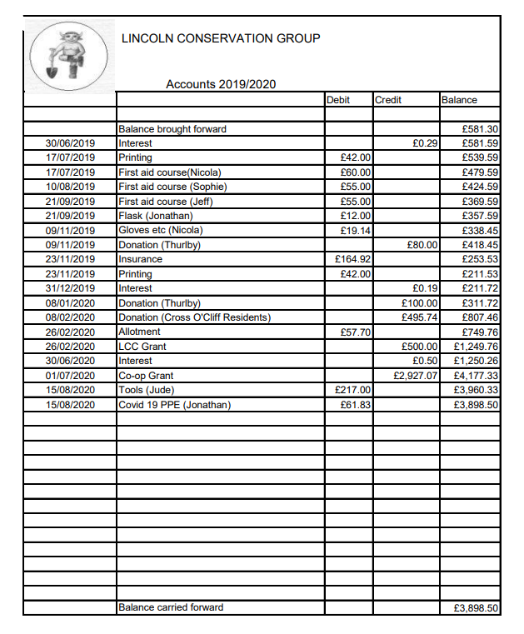

LINCOLN CONSERVATION GROUP
CONSTITUTION

1. The group shall be called Lincoln Conservation Group.

2. The aims of the group are:
- To promote practical nature conservation through volunteers for the benefit of Lincolnshire’s environment and the public.
- To educate the volunteers in the principles and practice of conservation.

3. To fulfil these aims:
a) The group will undertake practical conservation work.
b) The group may undertake other activities, in furtherance of its aims or for the benefit of the group, from time to time as the members see fit.
c) Money shall be raised when required, for example through occasional paid tasks/workdays and other fundraising activities as agreed by the members.

4. The area served is principally the greater Lincoln area but projects and activities may be undertaken elsewhere as seen fit by the members.

5. The organisation shall affiliate to TCV and shall observe the conditions of association.

6. Membership shall be open to anyone interested in taking an active part in the work of the group, either directly by volunteering or by giving support in other ways, but those under 16 years of age must be accompanied by a parent or guardian.

7. The group shall hold regular meetings (at least bimonthly) to discuss its policy and administration. All members shall be invited to these meetings, and each member will have one vote.

8. The business of the group will be carried out by a Committee elected at the Annual General Meeting. The Committee will include: chairperson, secretary, treasurer, task organiser, publicity officer, tools officer. These officers shall be in charge of the day-to-day running of the group but shall be answerable to meetings of members.

9. Accounts shall be kept by the treasurer, reported at the regular meetings and approved for each financial year at the AGM.

10. The organisation shall maintain insurance for volunteers on its projects, and for injuries to third parties and damage to property.

11. If, by general consent of its members, the organisation ceases to exist, all assets shall be offered to other local conservation groups or, failing that, to a conservation-based charity, as agreed by the members at the time of dissolving the group.

12. This constitution shall only be altered by consent of a majority of the members of the organisation.

